**DAILY ONLINE ACTIVITIES SUMMARY**

|  |  |  |  |  |  |  |  |  |
| --- | --- | --- | --- | --- | --- | --- | --- | --- |
| **Date:** | **23-06-2020** | | | | | **Name:** | **Shiza Amreen.J** | |
| **Sem & Sec** | **4th sem B Sec** | | | | | **USN:** | **4AL18CS078** | |
| **Online Test Summary** | | | | | | | | |
| **Subject** | | **IoT Webinar Quiz** | | | | | | |
| **Max. Marks** | | **15** | | **Score** | | | **11** | |
| **Certification Course Summary** | | | | | | | | |
| **Course** | **Introduction to Cyber Security** | | | | | | | |
| **Certificate Provider** | | | **GreatLearning** | | **Duration: 5.5 Hours** | | |  |
| **Coding Challenges** | | | | | | | | |
| **Problem Statement:**  **1.** [**Python Program to Split the array and add the first part to the end There is a given an array and split it from a specified position, and move the first part of array add to the end.**](https://github.com/orgs/alvas-education-foundation/teams/2nd-year/discussions/135)  **2.** [**Write a C Program to Sort a stack using a temporary stack**](https://github.com/orgs/alvas-education-foundation/teams/2nd-year/discussions/134). | | | | | | | | |
|  | | | | | | | | |
| **Status: Completed** | | | | | | | | |
| **Uploaded the report in Github** | | | | | **Yes** | | | |
| **If yes Repository name** | | | | | **Lockdown_Coding**  <https://github.com/ShizaAmreen/Lockdown_coding> | | | |
| **Uploaded the report in slack** | | | | | **Yes** | | | |

Online Test Details:

Today we had IoT Webinar Quiz, I have attended it and got 11 out of 15.

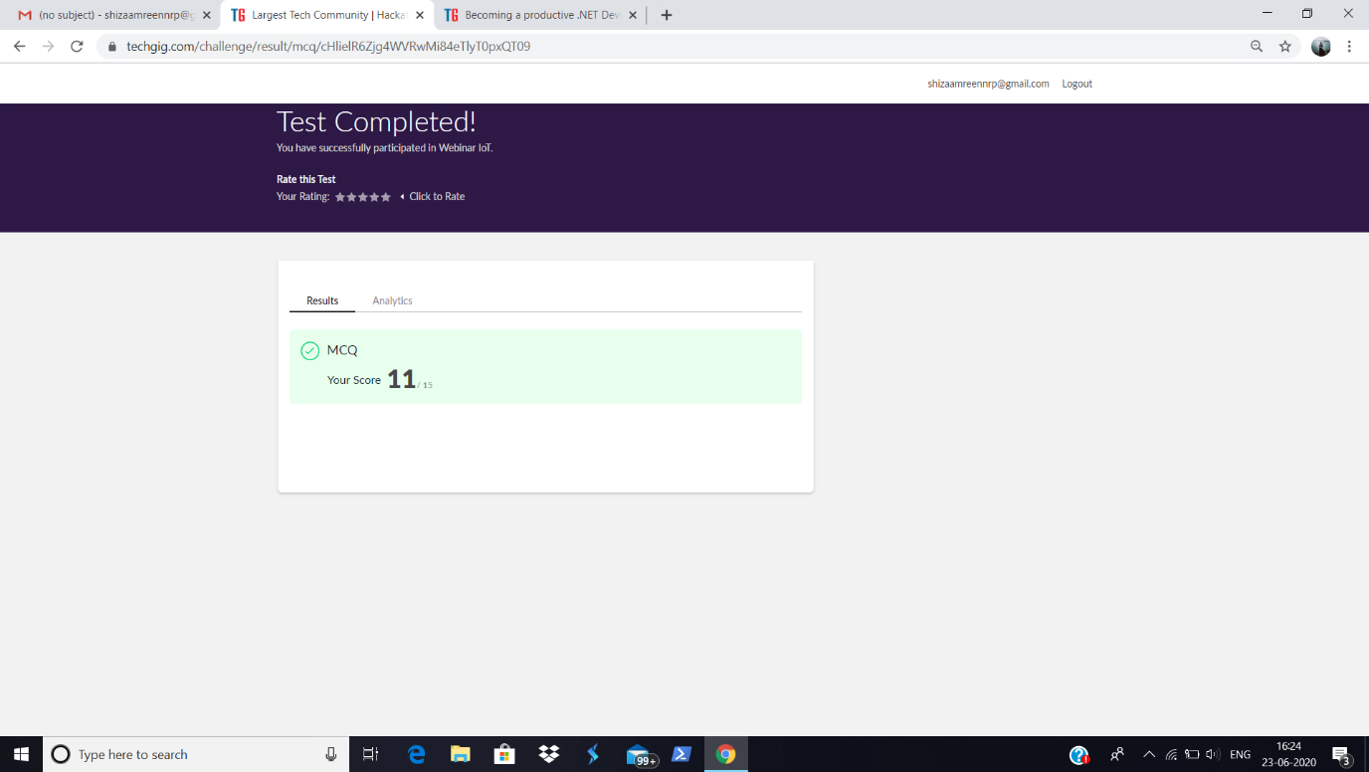

Certification Course Details:

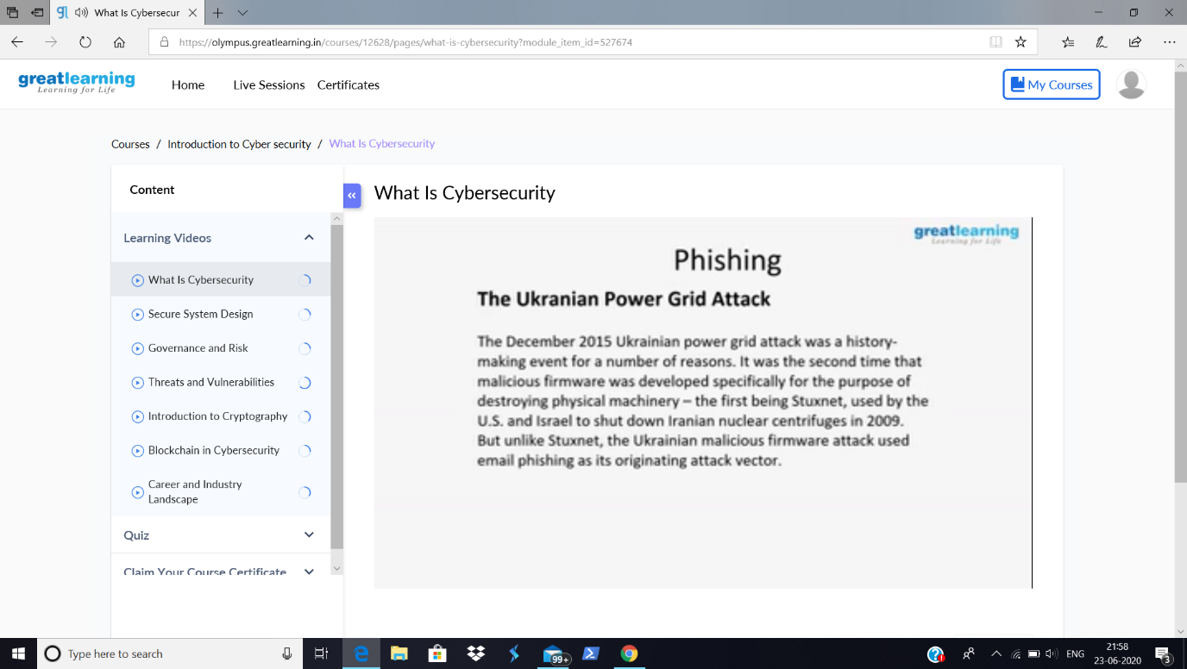

Today in the course, I have learnt about Phishing, The Ukranian Power Grid Attack.

Coding Challenges Details:

|  |
| --- |
| **Problem Statement:**  **1.** [**Python Program to Split the array and add the first part to the end There is a given an array and split it from a specified position, and move the first part of array add to the end.**](https://github.com/orgs/alvas-education-foundation/teams/2nd-year/discussions/135)  **2.** [**Write a C Program to Sort a stack using a temporary stack**](https://github.com/orgs/alvas-education-foundation/teams/2nd-year/discussions/134). |

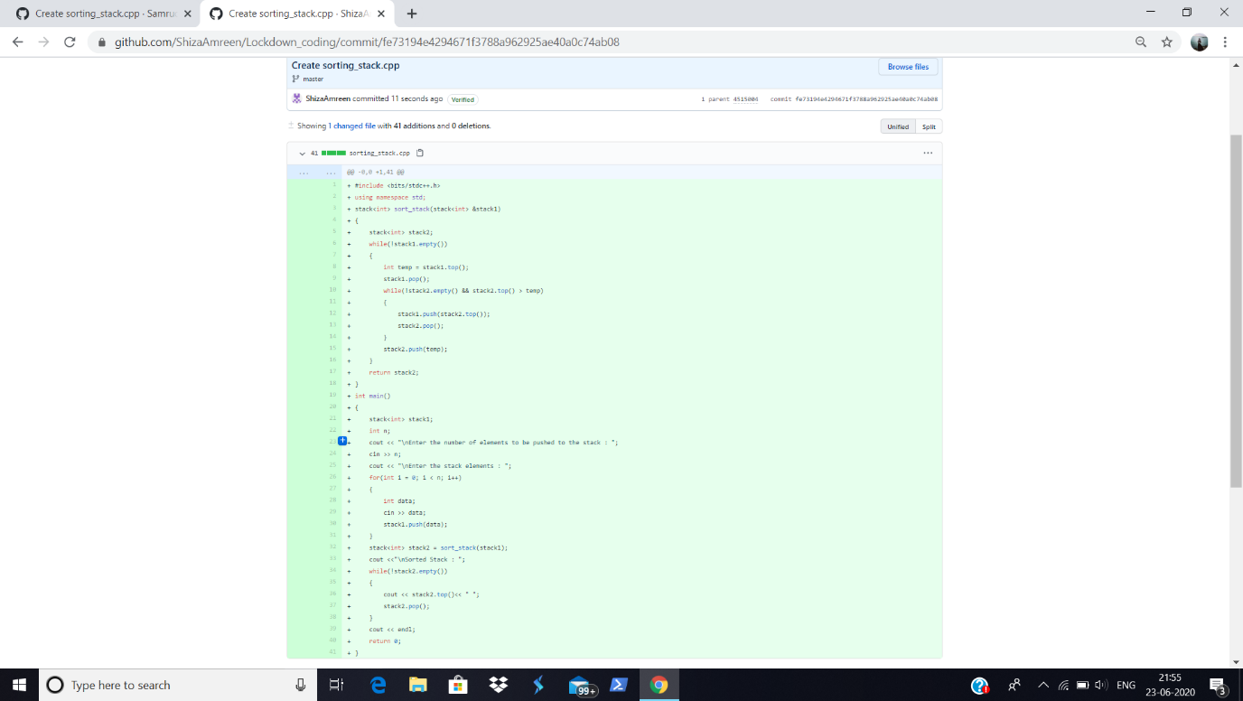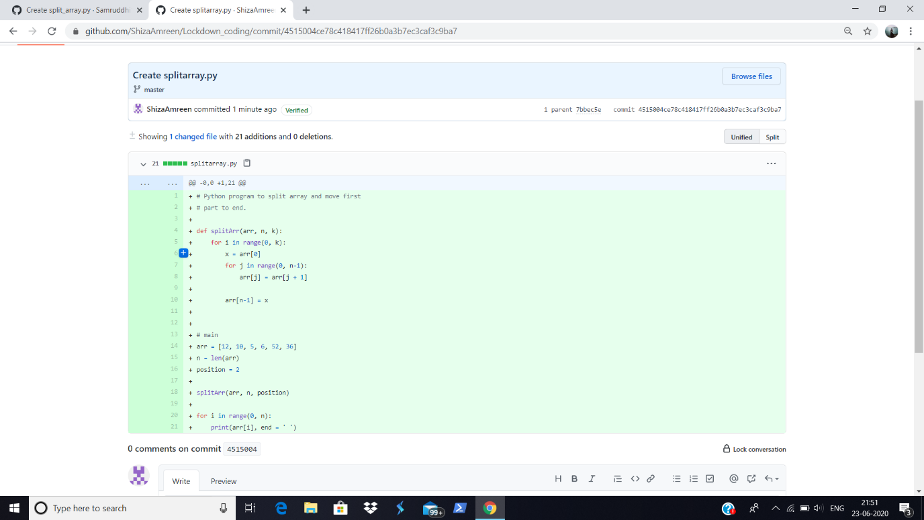

**I have written the code for given problem statement and uploaded it in my github repository, Lockdown_Coding.**

<https://github.com/ShizaAmreen/Lockdown_coding/commit/4515004ce78c418417ff26b0a3b7ec3caf3c9ba7>

<https://github.com/ShizaAmreen/Lockdown_coding/commit/fe73194e4294671f3788a962925ae40a0c74ab08>